E-COMMERCE REDESIGN
INTRODUCTION:
Project name:E-commerce redesign
Goal:Enhancing the user experience of an existing E-commerce platform
Role:UI/UX Designer and Researcher
Tools used:Figma
Project duration:4weeks
PROBLEM STATEMENT:
Users often face difficulties navigating large e-commerce grocery websites due to cluttered interfaces, inconsistent product categorization, and time-consuming checkout processes.
The challenge is to redesign BigBasket's website to make grocery shopping faster, easier, and more personalized - enhancing both usability and customer satisfaction.
USER RESEARCH:
a. Research Goals
Understand user behavior while shopping for groceries online.
Identify pain points in the existing BigBasket website.
Find opportunities to improve user convenience
Research methods:
Surveys - To gather opinions about online grocery shopping experiences.
User Interviews - To learn user preferences and frustrations.
Competitor Analysis - Compare with Amazon Fresh, Blinkit, and Zepto.
Usability Testing - Observe users interacting with the current website.
c. Key Findings
Users want faster search and filters.
Checkout process feels long and confusing.
Reordering frequently bought items is not easy.
Users prefer visible delivery times before checkout
INFORMATION ARCHITECTURE:
Main Sections:
1. Home
Banners, Offers, Categories, Search Bar
2. Shop by Category
Fruits & Vegetables
Dairy & Bakery
Staples
Beverages
Household Items
3. Search & Filter
Price range, Brand, Offers, Ratings
4. Cart
Edit quantity, remove items, view total
5. Checkout
Address, Delivery slot, Payment option.
6. Profile
Orders, Wishlist, Rewards, Settings, Help
USER FLOW/JOURNEY:
Scenario: User wants to buy groceries
1. Home Page ? User sees offers and categories.
2. Search or Browse Category ? Finds "Fruits & Vegetables."
3. Product Listing Page ? Filters by price or brand.
4. Product Details Page ? Adds items to cart.
5. Cart Page ? Reviews items, applies coupons.
6. Checkout Page ? Selects address, delivery time, and payment.
7. Order Confirmation ? Receives confirmation and tracking info.
WIRE FRAME:
A wireframe is a low-fidelity visual blueprint of a webpage or app screen that shows the structure, layout, and functionality without design details like colors or images.
For BigBasket, the wireframe represents how users navigate and interact with the grocery e-commerce platform before the actual design phase.
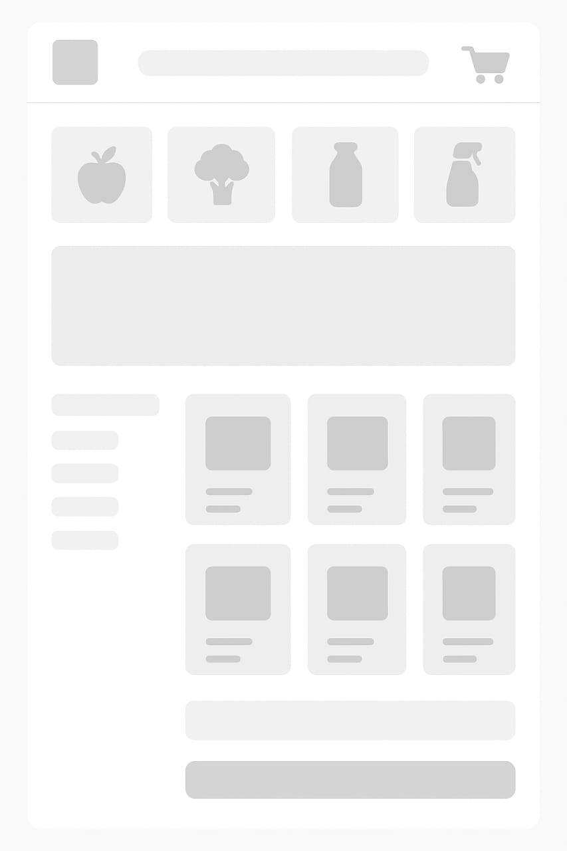
UI DESIGN:
UI design for the BigBasket app means creating a clean, easy-to-use, and attractive interface that helps users browse, search, and buy groceries quickly.
It focuses on making every screen - from home to checkout - simple, colorful, and comfortable to use on any device.
"UI design for BigBasket is about making the grocery shopping app look modern, feel smooth, and help users shop easily with clear buttons, neat layouts, and friendly visuals."
Prototype and interactions:
Clickable prototype made in Figma
Smooth page transitions (Home ? Category ? Product ? Cart)
Buttons respond with light animations or color changes
"Add to Cart" shows a small pop-up confirmation
Swipe gestures to remove or save items in cart
Real-time order tracking animation
Interactive icons and menus for easy navigation
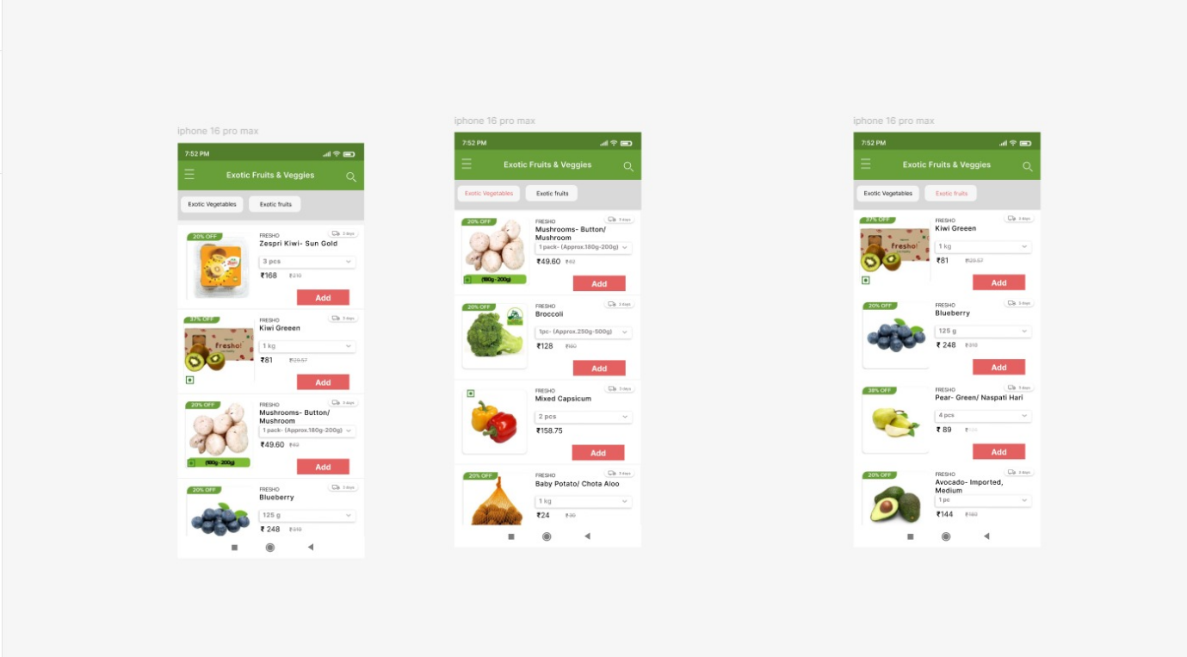
CONCLUSION:
The redesigned BigBasket app gives users a faster, cleaner, and friendlier shopping experience
Simple layouts make it easy to find and buy products
Interactive features add fun and comfort while shopping
The new design helps BigBasket look modern and user-focused, improving both usability and satisfaction

